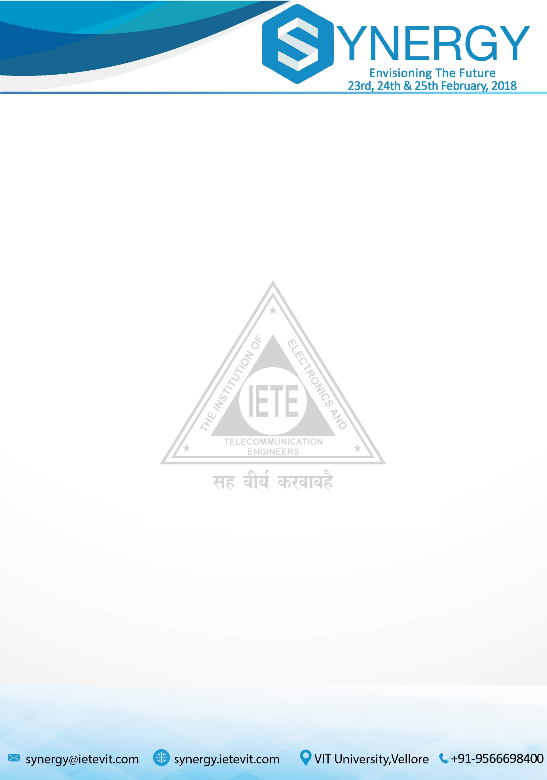

To

DEAN SENSE

VIT University

Vellore, TN.

6th November 2017.

Respected Sir/ Ma’am,

Subject: Request for approval of budget of Synergy’18.

The Institution of Electronics and Telecommunication Engineers (IETE) is a leading technical chapter of VIT University devoted to the advancement of science and technology. IETE has been diligent in conducting events, workshops, industrial visits, social initiatives and symposiums in the past with great zeal and has achieved success in its endeavours. Synergy is a national level symposium which is being conducted annually for the past four years in collaboration with School of Electronics Engineering (SENSE).   
  
Synergy’18, a three-day symposium will be conducted on 23rd, 24th and 25th February, 2018 in collaboration with SENSE- VIT. The symposium will be open to students from all branches from various colleges in and around Tamil Nadu. This symposium will be conducted for the fifth time in a bigger and better way.

Attached is the budget for Synergy’18 for reference.

We request you to approve it.

Thank you for your cooperation.

Shubham Jain Prof. Kishore V Krishnan

**President IETE Faculty Co-Ordinator IETE DEAN-SENSE**

# 

# OVERALL BUDGET

|  |  |  |  |  |
| --- | --- | --- | --- | --- |
| ITEM | NO. OF PARTICIPANTS | PER Student | INCOME | EXPENDITURE |
| Workshop 1  (Annexure A) | 80 | 900/700 | 70000 | 40000 |
| Workshop 2  (Annexure B) | 80 | 1000/800 | 78000 | 51000 |
| Workshop 3  (Annexure C) | 80 | 900/700 | 70000 | 55000 |
| Paper Presentation  (Annexure D) | 100(max 3 per paper) | 500 | 50000 | 30900 |
| CodeOlympia  (Annexure E) | 70(teams) | 300 | 21000 | 17000 |
| UHET Fund  (Annexure F) |  |  |  | 5000 |
| Cultural night  (Annexure G) | 200 | 350 | 70000 | 60000 |
| Android App Development (Seminar/Workshop)  (Annexure H) | 100 | 200 | 20000 | 0 |
| Miscellaneous  Expense  (Annexure I) |  |  |  | 32160 |
| Accommodation  (Annexure J) |  |  |  | 15000 |
| Travel  (Annexure K) |  |  |  | 40000 |
| TOTAL |  |  | **379000** | **346060** |

## 

## ANNEXURE A

#### A TWO-DAY WORKSHOP ON DATA ANALYTICS AND MACHINE LEARNING USING PYTHON BY SCIENTIFIC COMPUTING SOLUTION.

##### **REVENUE GENERATED:**

|  |  |
| --- | --- |
| Payment to the training company | Rs. 40,000 |

**Budget Plan assuming a turnout of 80 participants**

|  |  |
| --- | --- |
| Registration Fee (per participant) | Rs.900 |
| Registration Fee (IETE Members) | Rs.700 |
| Revenue generated on 80 participants (70 participants + 10 IETE Members) | Rs.70000 |

Revenue generated from Data Analytics and Machine Learning:

Rs.70000- Rs.40000 = Rs.30000

## 

## ANNEXURE B

#### A TWO-DAY WORKSHOP ON VLSI DESIGN BY HT INDIA LABS.

**REVENUE GENERATED – VLSI DESIGN:**

**Budget Plan assuming a turnout of 80 participants**

|  |  |
| --- | --- |
| Registration Fee (per participant) | Rs.1000 |
| Registration Fee (IETE Members) | Rs.800 |
| Revenue generated on 80 participants (70 Non IETE + 10 IETE members) | Rs. 78,000 |

|  |  |
| --- | --- |
| Payment to the training company for 80 participants | 65% of Total income =  Rs. 51,000 |

Revenue generated from VLSI Design:

35% of the revenue generated on 80 participants = 27,000

# 

# **ANNEXURE C**

#### A TWO-DAY WORKSHOP ON WIRELESS VOICE CONTROLLED ROBOTICS

**REVENUE GENERATED – ROBOTICS:**

**Budget Plan assuming a turnout of 80 participants**

|  |  |
| --- | --- |
| Registration Fee (per participant) | Rs.900 |
| Registration Fee (IETE Members) | Rs.700 |
| Revenue generated on 80 participants (70 Non IETE + 10 IETE members) | Rs. 70,000 |

Robotics Kits for Participants = 1500*30= Rs. 45,000

Trainer Fee=Rs. 10,000

Total Expenditure= 10000+45000= Rs. 55,000

Revenue generated from Robotics Workshop:

Rs.70, 000 **–** Rs. 55,000= Rs. 15,000



# **ANNEXURE D**

PAPER PRESENTATION IN COLLABORATION WITH IJRASET:

**REVENUE GENERATED – PAPER PRESENTATION:**

**Income:**

Expected number of participants = 100

(Max 3 participants/team)

Registration Fee per participants= Rs.500

Income = 100* 500 = Rs. 50,000

**Expenditure**

Prize Money (per category):

First Prize: Rs.2000

Second Prize: Rs.1000

Total Prize Money= Rs. 9,000

IETE Publications = Rs.1000

Publication Fee= Rs.800 per paper

Payment = 800*23 = Rs. 18,400



|  |  |  |
| --- | --- | --- |
| **ITEM** | **PRICE** | **QUANTITY** |
| **Delegate kit** |  | 50 |
| **Pen** | 10 |  |
| **Folder** | 20 |  |
| **Conference pad** | 20 |  |
| **Total (Kit)** | 50 |  |
|  | **Total Amount** | 50*50=2500 | |
|  |  |  | |
|  | **Total Expenditure** |  | |
|  |  | Rs.2500+Rs9,000+Rs 18,400+Rs.1000= Rs. 30,900 | |
|  |  |  | |

# 

# Revenue Generated:

Rs. 50,000- Rs. 30,900= Rs. 19,100



# **ANNEXURE E**

## CODEOLYMPIA

**REVENUE GENERATED – CODEOLYMPIA:**

**Income:**

Expected No. of teams = 70

Registration Fee = Rs.300/team (max 2 participants in a team)

Total Income = Rs.21000

**Expenditure:**

Refreshments = Rs.8000 (Rs.50*160)

Prize Money:

1st Prize=Rs.4000

2nd Prize =Rs.3000

3rd Prize=Rs.2000

Total Prize Money = Rs.9000

Total Expenditure = Rs.8000+ Rs.9000 = Rs. 17,000

Revenue Generated =

Rs. 21,000- Rs. 17,000= Rs. 4,000

## 

## ANNEXURE F

## SOCIAL INITIATIVE

IETE has undertaken a social initiative to raise funds for the Universal Higher Education Trust (UHET) through Synergy’18. UHET is a tru which provides a platform for the students, whose family income is not enough for the completion of their education, to complete their school education and college education. It would be a privilege for IETE to contribute for such a noble cause.

Donation = Rs.5000

## 

## ANNEXURE G

## CULTURAL NIGHT

**REVENUE GENERATED –CULTURAL NIGHT:**

**Income:**

Total Participants = 200

Registration Fee=Rs.350

Total Income =200*350=Rs.70000

**Expenditure:**

|  |  |  |  |  |
| --- | --- | --- | --- | --- |
| SL | ITEM | Price | Quantity | Total |
| 1 | Caterers | 200 | 250 | 50000 |
| 2 | Decoration |  |  | 10000 |
|  |  |  | TOTAL | 60000 |

Revenue Generated=

Rs. 70,000- Rs. 60,000= Rs.10000

## 

## ANNEXURE H

SEMINAR/ WORKSHOP ON ANDROID APP DEVELOPMENT

**REVENUE GENERATED:**

Registration Fee = Rs.200

Expected No. of participants = 100

Income = Rs.20000

## 

## ANNEXURE I

## MISCELLANEOUS BUDGET

|  |  |  |  |
| --- | --- | --- | --- |
| ITEM | PRICE | QUANTITY | COST |
| TAG | 15 | 300 | 4500 |
| 10x10 Flex+ banner | 1500+780 | 2+2 | 4560 |
| Certificates | 10 | 500 | 5000 |
| Mementos | 1000 | 3 | 3000 |
| Brochures | 50 | 100 | 5000 |
| Stationery+ |  |  | 5000 |
| Additional |  |  | 5000 |
| Stamp For Entry(cultural night) |  |  | 100 |
|  |  | TOTAL | 32,160 |
|  |  |  |  |

## 

## ANNEXURE J

ACCOMMODATION & HOSPITALITY

|  |  |
| --- | --- |
| ITEM | EXPENDITURE |
| 1 room for 1 day (Chief Guest) | 1*2000= Rs.2000 |
| 2 Guest rooms for 2 days(trainers) | 2*2*2000 = Rs.8000 |
| Food | Rs.5000 |
| Total | Rs. 15,000 |



**ANNEXURE K**

TRAVEL

|  |  |
| --- | --- |
| ITEM | EXPENDITURE |
| 2 AC Cab for Speakers and CG (Chennai-Vellore), (Vellore - Chennai) | (6000*2) = Rs.12000 |
| Ticket Charges for CG  Flight Expenses for Speakers | 10000  10000 |
| AC Cab for 3 days | Rs.8000 |
| Total | Rs. 40,000 |



**COMBOS**

**Combo 1 Induvial Registration FEE**

1. Machine Learning Workshop Rs.900
2. Guest Lecture Free
3. Android App Development Workshop Rs.200
4. Cultural Night Rs.350
5. Seminar Free

**TOTAL Rs.1450**

**Registration Fee = Rs.1400**

**Combo 2 Induvial Registration FEE**

1. VLSI Design Workshop Rs.1000
2. Guest Lecture Free
3. Android App Development Workshop Rs.200
4. Cultural Night Rs.350
5. Seminar Free

**TOTAL Rs.1550**

**Registration Fee = Rs.1500**



**Combo 3 Induvial Registration FEE**

1. Wireless voice controlled robotics workshop Rs.900
2. Guest Lecture Free
3. Android App Development Workshop Rs.200
4. Cultural Night Rs.350
5. Seminar Free

**TOTAL Rs.1450**

**Registration Fee = 1400**

**Combo 4 Induvial Registration FEE**

1. Codeolympia Rs.900
2. Guest Lecture Free
3. Android App Development Workshop Rs.200
4. Cultural Night Rs.350
5. Seminar Free

**TOTAL Rs.1450**

**Registration Fee = 1400**



**Combo 5 Induvial Registration FEE**

1. Paper Presentation Rs.500
2. Guest Lecture Free
3. Android App Development Workshop Rs.200
4. Cultural Night Rs.350
5. Seminar Free

**TOTAL Rs.1050**

**Registration Fee = 1000**